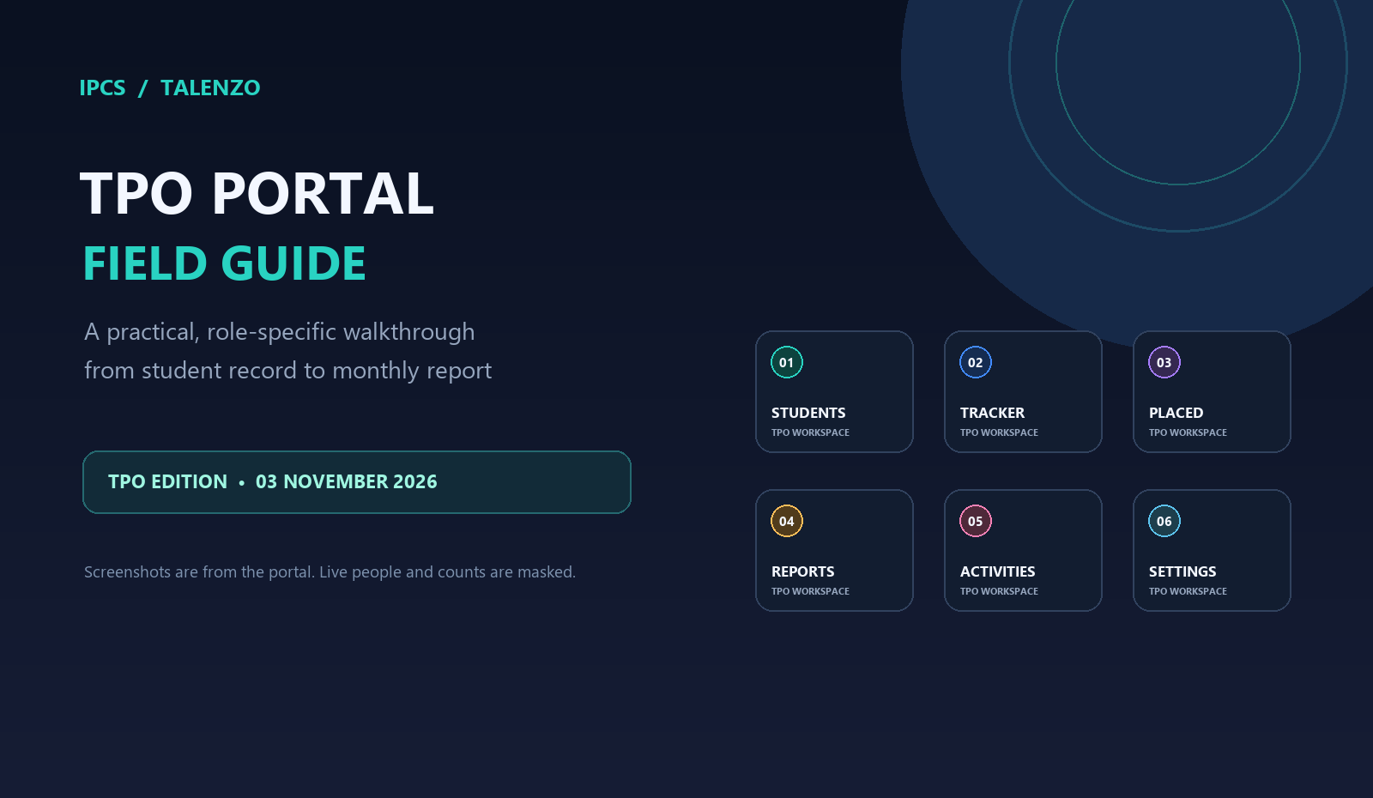
A complete start-to-finish handbook for Placement Officers (TPOs). Use it to find the right tab, record work once, understand where each update goes, and check reports with confidence.
Who this guide is for
TPO accounts only. Admin-only tools such as user administration, security audit, system settings, and Gifty’s delete-approval desk are described only where they affect the TPO workflow.
Prepared from the portal screens and current application workflow reviewed on 03 November 2026. The portal is updated over time; labels or visible options may vary slightly by assigned role.

START HERE

The TPO workspace in one minute
The portal is a set of focused work areas. Your account controls which branches and functions you can see. A search box or filter narrows your view; it does not grant access to another branch.
Portal tab | Use it for | Main record source
Dashboard | Quick view of placement work, learner totals, pending eligibility, and upcoming drives. | Several sources summarized
Students Directory | Find a learner, review profile, update eligible course and placement fields. | Data
Issue Resolution | Review and update assigned branch issues. | Issues
Job & Drive Tracker | Track drive registrations, applications, interviews, and follow-up. | Drive_Registration, Opening_Applied, TPO_Log
Reports | Monthly target report, branch matrices, placement tracker, and TPO activities. | TPO_Log, TPO_Stats, Events
Placed Students | Add, review, or edit placement events; request deletions for approval. | TPO_Log; Placed_Students view
Student Apps | Review applications and drive registrations in one list. | Opening_Applied, Drive_Registration
Vacancies | Create and manage internal job opening listings. | NewsLetter
Clients & Partners | Maintain employer/contact information. | Clients
Events | Schedule or review branch events and placement drives. | Event
Talentino | Review Talentino sessions, attendance, and ratings. | Talentino_Schedule, Talentino_Attendance
Exams Hub | Open role-enabled exam and assessment areas. | Assessment modules
News & Blog | Browse career/news content. | News/content service
GamePal | Open practice games. | Personal practice state
Settings | Update your profile photo and workspace appearance. | User profile / local preferences

Remember the placement source
TPO_Log is the canonical placement event record. Placed_Students is a list view that can be rebuilt from it. If a placement is missing, check the source row and sync status before adding the same placement again.

HOW THE RECORDS MOVE

A simple data map
The portal writes through its service to the appropriate Google Sheet tab. Different actions use different sheets; a job application is not automatically a placement.
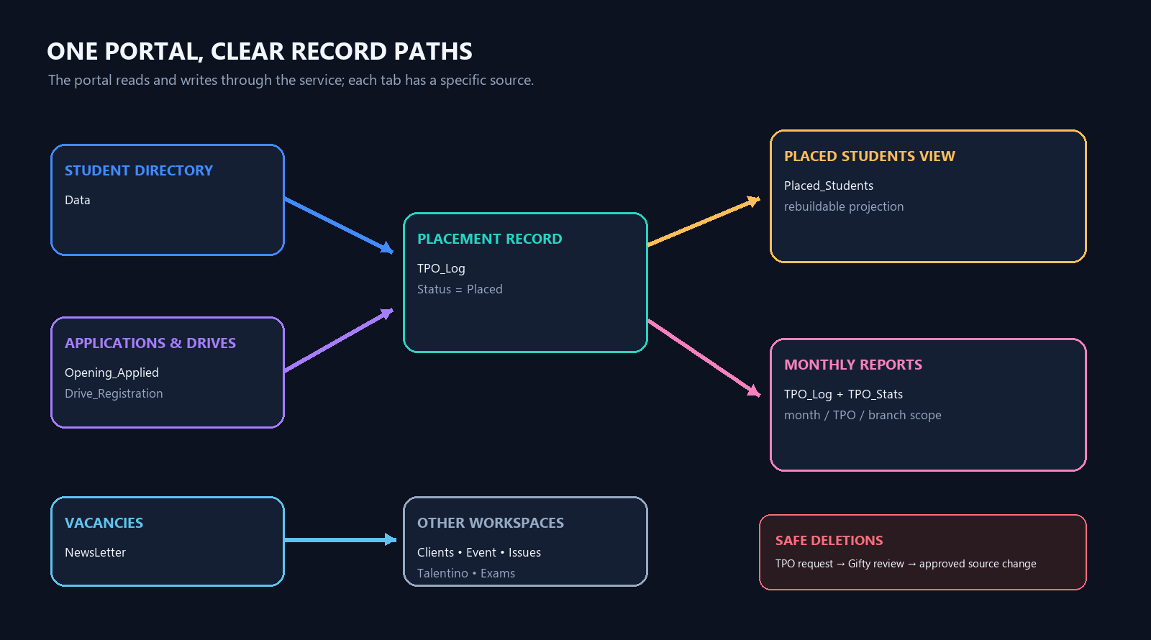
Figure 1. Simplified data path. “Placed_Students” is a projection from the canonical placement log.
Action you take | What gets recorded | What it means
Edit student profile/status | Data | Current learner profile and placement eligibility status.
Student applies / drive registration | Opening_Applied / Drive_Registration | An application or registration—not a placement by itself.
Record a placement | TPO_Log; matching application updated when available; Placed_Students rebuilt | One placed row is one placement event, including a repeat placement.
Set monthly target / activity | TPO_Stats | Target or monthly outreach/social activity report.
Create vacancy / client / event / issue update | NewsLetter / Clients / Event / Issues | Separate business records for those tabs.

Portal first
Use the portal for normal work. Avoid editing sheet cells directly unless your administrator has explicitly assigned you that job; direct edits may bypass validation, ownership, sync, and audit steps.

01 • HOME

Dashboard
The Dashboard is your starting summary. It is meant to answer “what is happening in my scope?” and provide quick paths into the work tabs.
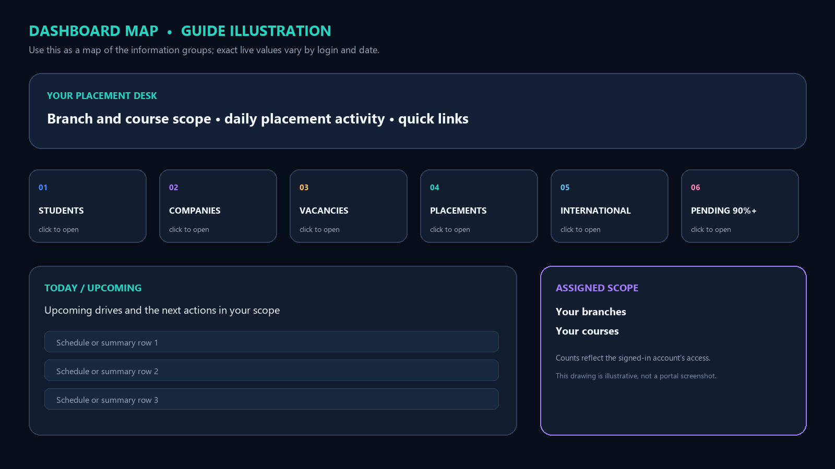
Figure 2. Dashboard map for training; this is a guide illustration, not a live portal screenshot.
Card / area | Plain meaning
Students | Learners visible in the signed-in account’s assigned scope.
Companies | Employer records available in the portal.
Active vacancies | Open job listings, not number of students hired.
Total placements | Placement events recorded; repeat placement rows count as separate events.
International placements | Placement rows marked international through the location confirmation.
Placement pending | Students in Pending / Placement Needed (including Pending for Placement) with at least 90% course completion.
Upcoming drives | Scheduled upcoming events in the account’s accessible scope.

Example
A student is at 89% and marked “Placement Needed”: not eligible for the 90% pending count yet. At exactly 90%, with that status, the student qualifies. A student at 95% marked “No Need of Placement” does not qualify.
Dashboard figures may be all-time or current-scope summaries depending on the card label. Use the report month and TPO scope for month-specific performance; do not compare a monthly number to an all-time card.

02 • LEARNERS

Students Directory
Use this tab to locate a student before changing a current student record.
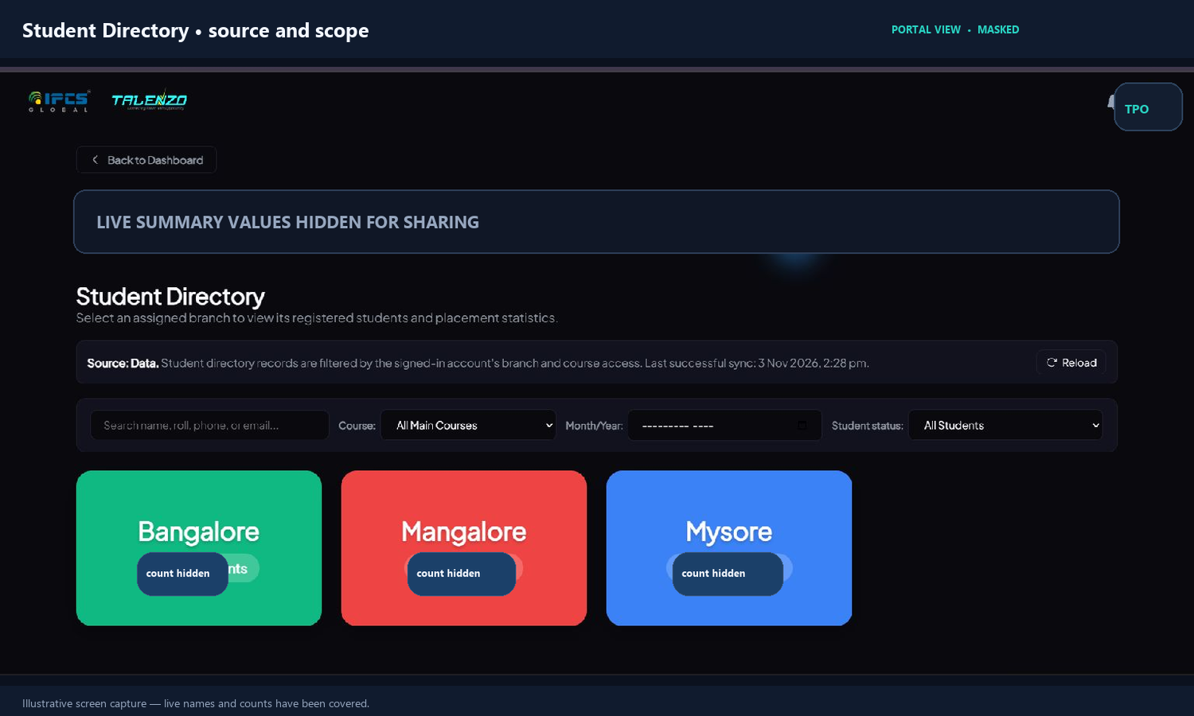
Figure 3. Student Directory screen; live metric values and branch counts are hidden.
1. Choose the assigned branch or use the visible branch cards. The page states that its records are filtered by the signed-in account’s branch and course access.
2. Search by student name, roll number, phone number, or email. Course and month/year filters help narrow the list; the student status filter shows the current learner status.
3. Open the student details to review contact information, qualification, course, branch, course percentage, joining date, resume/certificate fields when present, and placement activity counts.
4. Where your account has edit permission, update the relevant field and choose Save Changes. Wait for the success message and confirm the changed value after the list refreshes.
If you change a learner’s placement status to Placed, answer the international/domestic question when it appears. Confirm the placement details are recorded in the placement register before leaving the student record.
The placement activity section can show openings applied/attended, interviews attended/not attended, and offers rejected when those source records exist. These are application activity counts, not the placed-row total.
Example
Search “Asha”, then check the roll number to choose the right person if several results have similar names. If course completion moves from 80% to 90%, save it here; the eligible-pending summary should use the updated value after the data refresh.
Important boundary
A TPO can work only within the branches/courses enabled for that login. Admin-only student fields and system controls may be read-only or unavailable.

03 • FOLLOW-UP

Issue Resolution
This is the queue for student or operational issues assigned to your branch scope. Open an item, review the description and history, set its status or add a note if enabled, then save. Use factual notes such as “Called on 3 Nov; student requested a callback Thursday.”
Typical step | What happens
Open branch / issue list | The portal shows issues in your permitted scope.
Review details | Read the report, existing status, owner, and prior notes.
Update status / note | Your change is saved to the issue record and can be audited.
Verify after saving | Confirm that the status badge and last-updated value changed.

Good practice
Do not put unnecessary personal or sensitive details into a free-text note. Keep the note relevant to the next action.

Job & Drive Tracker
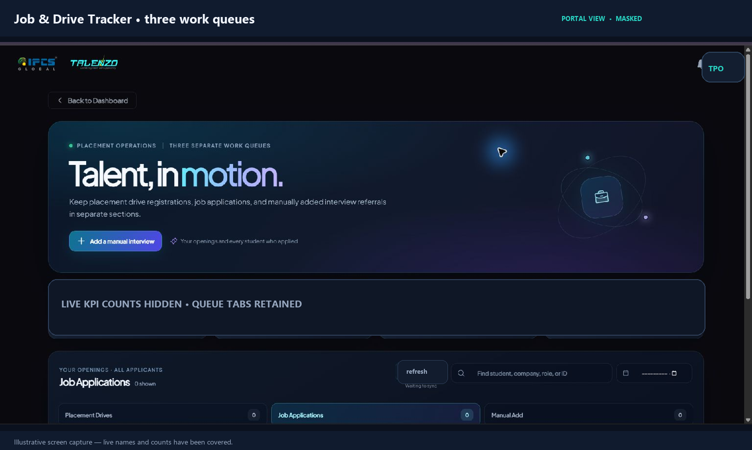
Figure 4. Tracker view. Queue counts and sync indicators are masked for this guide.
This tab puts three work queues side by side: Placement Drives, Job Applications, and Manual Add. The counts at the top summarize tracked records, follow-ups, interviews, and offers/placements.
- Placement Drives: review students registered for a scheduled drive and their progress through its stages.
- Job Applications: review applications to openings, follow-up/interview status, and outcomes.
- Manual Add: log an interview/referral that was arranged outside the portal. Capture the student, company, role, date/time, venue or meeting details, and status that the form requests.
Application is not placement
A student applying, registering, or attending an interview does not count as placed. Record the placement only when the student has actually been placed, using Placed Students or the approved placement action.

04 • APPLICATIONS AND OPENINGS

Student Apps
Student Apps is a consolidated review list for applications and drive registrations. Use it when you want to see what students have applied to or registered for without treating those records as completed placements.

Student Apps: what to do
Filter by source, branch, course, month, or status when those controls are shown. Open a record to review the student and opportunity, then use the available action to update the application stage.
Example: A student registered for the October drive appears in Drive Registration. Mark interview progress in the application workflow; add a placement only after a confirmed hire.
Data: Opening_Applied and Drive_Registration.
Access: Visible actions depend on TPO role and assigned branch/course scope.

Vacancies
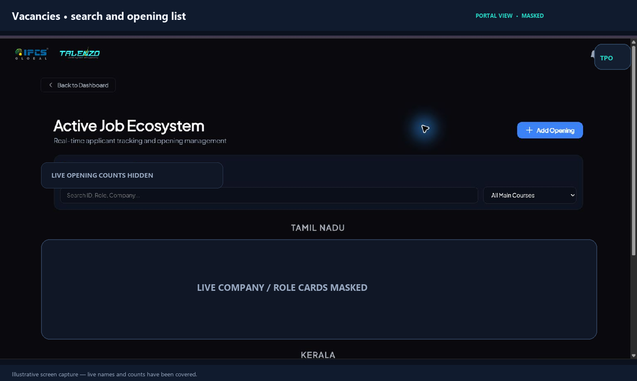
Figure 5. Vacancy list. Live company names, role cards, and opening counts are masked.
- Use Active Openings for roles currently open, and Expired / Closed for historical listings.
- Search by job ID, role, or company. Use the main-course filter to narrow the list.
- Add or edit a listing using the form’s role, company, location, course, date, and other required fields.
- View applicants to review who applied. If the list or action panel appears blank/blurred, close it and retry once; then report the opening ID and a screenshot to support.
- TPO deletion is a request, not an immediate delete. Include a reason and wait for Gifty’s approval.
Vacancies are internal portal listings stored in NewsLetter. Creating a vacancy does not itself mean a placement occurred.

05 • PLACEMENT REGISTER

Placed Students: add, review, edit
This is the most important placement record tab. Before saving, check the student identity, company, role, placement date, branch/course, and joining status carefully.
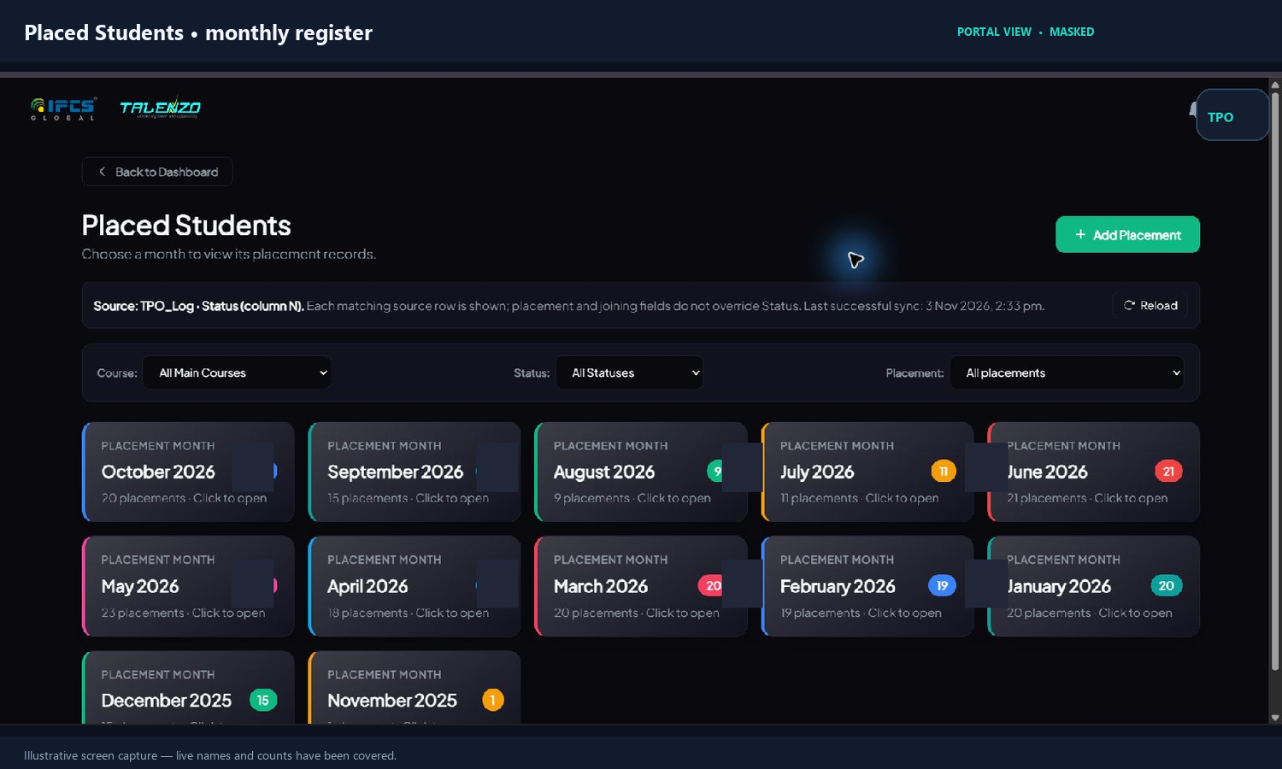
Figure 6. Monthly placed register. Current month counts are masked; the source banner is retained.
Filter by month, main course, joining status, or placement type (International / Within India). The report’s International chip opens those records.

Add a placement
1. Click Add Placement and select or enter the student using a reliable identifier. Prefer roll number; confirm phone/email if the roll number is missing.
2. Enter employer, position, job location (state/country), placement date, package if known, joining status, offer letter, and remarks requested by the form.
3. When asked whether the placement is international, choose accurately. A placement outside India is international; one in India is domestic.
4. Save once. Wait for the confirmation, then verify that the row appears in the selected month. If a sync warning appears, note the message and ask for a source refresh before retrying to avoid duplicates.

Edit an existing placement
Open the correct row and use Edit to change position, date, package, joining status, offer letter, or remarks when available. Save and verify the same row. Each placement event has its own joining-status classification; editing one row should not automatically mark a different company’s row dual or multiple.
Canonical data rule
TPO_Log is the source. Each source row with Status=Placed counts as a placement; Joining Status describes the follow-up and never replaces Placed status.
05 • PLACEMENT RULES

International, dual, multiple, and joining
These values describe the placement row and are used by dashboards/reports. Use the suggestion as a prompt to check the history; the TPO makes the final choice.
Field / label | Meaning | Example
International | The TPO confirms whether the job location is outside India. | Student hired in Dubai → International. Job in Bengaluru → Within India.
Joined | The student has joined the employer. | A confirmed joining date or confirmation is received.
Not Joined | The student did not join. | Student declines or does not join after confirmation.
Pending Joining | The joining outcome is not known yet. | Offer accepted; joining date is next month.
Dual Placement | Same student, different company, same calendar month. | Company A on 10 Oct and Company B on 22 Oct → the second row can be marked Dual.
Multiple Placement | Same student, different company, in a different month or year. | Company A in Oct; Company B in Dec → second row can be marked Multiple.

What the suggestion does
The portal can show an information/reminder suggestion after comparing prior placement rows. It does not automatically change the dropdown or label. Choose Dual Placement or Multiple Placement in the Joining Status field only when that row fits the rule.
How reports count
Every canonical TPO_Log row with Status=Placed counts as one placement event, even if the same student has another row. Dual and Multiple are separate labels/counts from the joining-status field; they do not remove a placement row from the total.
For an international placement, set the international choice on the placement event. The choice is shown on the placed record and summarized in the placement report. If the international tag is missing, edit the specific row and correct it; do not change another company’s row.

Requesting a deletion
Use Request delete on the exact placed row and include a clear reason. The request goes to Gifty’s Delete Record Approvals view. Gifty can approve or reject it; a TPO cannot approve their own request. Only after approval does the source row (and a matching application row, if found) get deleted. The placed-student projection is then refreshed.
Before requesting deletion
Check student, employer, date, and source row. A wrong edit is often safer to correct with Edit; reserve deletion for a truly incorrect/duplicate source record.

06 • MONTHLY OVERSIGHT

Reports
Choose the reporting month first. The page contains four inner tabs, plus report email actions for TPO accounts. The selected month changes the monthly figures and target comparison.
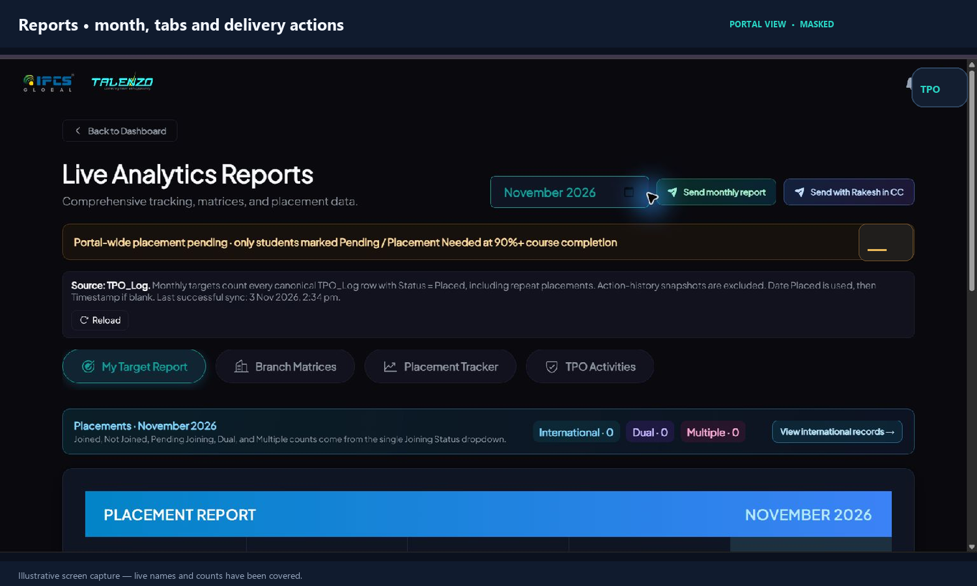
Figure 7. Reports page. The live global pending count and profile image are masked.
Do not mix these two numbers
A banner labeled “Portal-wide placement pending” is a portal aggregate. Your individual monthly report and email are tied to the TPO and assigned branch scope. The dashboard’s portal-wide banner is not your personal monthly target or your branch-only pending total.
Inner tab | What it shows / how to use it
My Target Report | Your selected-month placement register, target, course breakdown using the five main courses, international/dual/multiple counts, and logged placement records.
Branch Matrices | Branch/course views for placement and related counts in the accessible scope.
Placement Tracker | Placement follow-up and student placement records. Use it to inspect outcomes, not just the headline number.
TPO Activities | Monthly companies visited, drives, poster/video items, and other activity records; add or edit the report-month activity.

How placement totals and targets work
- The monthly report counts each canonical TPO_Log row marked Status=Placed whose Date Placed is in the selected month; if Date Placed is blank, Timestamp is the fallback.
- Repeat placements are not deduplicated: two companies for one student means two placement rows and two placements if both are recorded as Placed.
- Action-history snapshots in TPO_Log are excluded from placement totals. The marker “TPO Action Log” is audit/history context; it is not the actual placement status.
- The TPO’s target is month-specific. Gifty/admin records it in TPO_Stats for a selected month; October’s target does not overwrite November’s target.

Send a monthly report
Button | Recipients
Send monthly report | To gifty@ipcsglobal.com; CC includes the sending TPO.
Send with Rakesh in CC | To gifty@ipcsglobal.com; CC includes the sending TPO and rakesh@ipcsglobal.com.

Each button sends a separate new email for the selected month; it is not meant to append to an old mail thread. Check the chosen month, TPO activity entries, and placement rows before sending.
Five-point pre-send check
1) Month is correct. 2) Your target and TPO/branch scope are correct. 3) Every placed row has the right company, date, status, and international choice. 4) Activity items use the correct title, link, and Completed/Pending to post value. 5) Choose the intended recipient button; the two buttons send separately.

07 • MONTHLY EVIDENCE

TPO Activities: add and edit
This tab captures the work behind the monthly report: companies visited, placement drives, and social posts/videos. Select the report month and the activity owner before saving.

Add a monthly activity
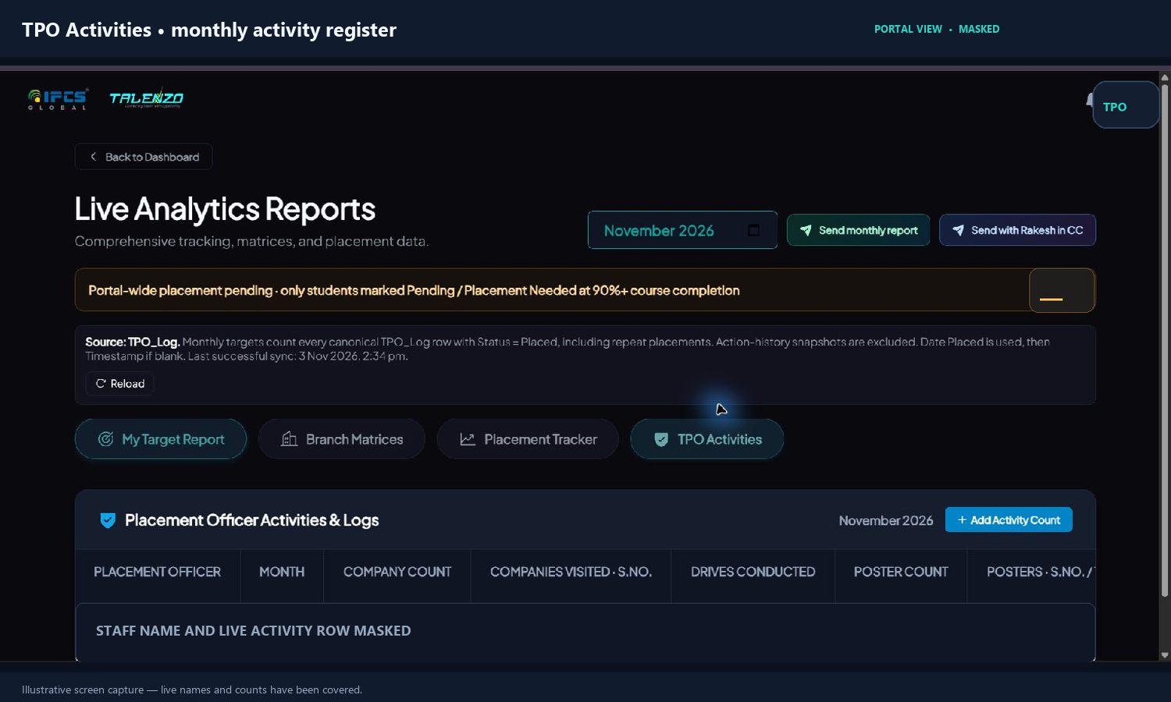
Figure 8. Activity register. The staff name and live row are covered.
1. Open Reports → TPO Activities. Confirm the month shown at the top matches the month you are reporting.
2. Click Add Activity Count. Choose the month and owner. Add one activity row for each item you want to report.

Complete the item and save
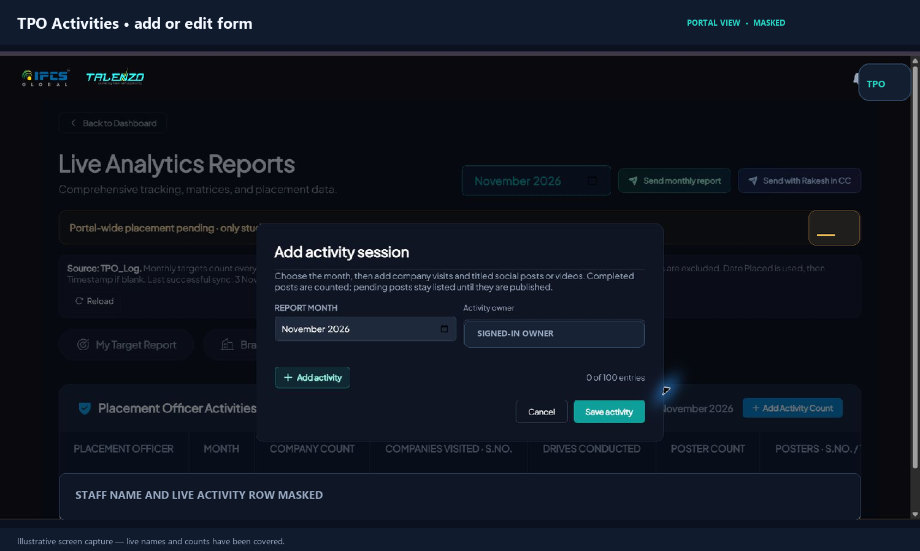
Figure 9. Add Activity form. The owner name is hidden; form fields remain visible.
1. Choose the type: Company Visit, Instagram Poster, Instagram Video, LinkedIn Post, or LinkedIn Video (the exact options may vary with portal release).
2. For Company Visit, enter company names one by one; the form supports up to 10 names in the visit group. For a post/video, enter a title or name, its http/https link, and Post completed or Pending to post.
3. Save. Use Edit on the activity row later to correct or add items for that same month.
What counts in the report
Company visits are displayed with serial numbers and count. Poster/video items show serial number and title. Completed posts/videos count as published; Pending to post stays listed but is not counted as published until completed. Use a valid full http:// or https:// link for completed posts.
What is calculated elsewhere
Drive counts come from the Events records. Application, joining, and placement totals come from their portal records; adding an activity description does not create a drive or placement by itself.

08 • EMPLOYER WORK

Clients & Partners
Use this area to find and maintain employer contact records that support openings and outreach. Search the company before creating a new one to avoid duplicate records.

A client record is not a placement
Company name, website, city/state, phone/email, contact person, and logo can be stored here. A client can be connected to opportunities later; the company record alone does not add a placed student.
Example: Add “Northstar Controls” as a client contact. Later, create an opening or record a confirmed student placement under that employer.
Data: Clients.
Access: TPO access depends on account role; some technical/trainer account types do not see Clients & Partners.

Events

Schedule branch work
Create or review an event with its date/time, branch, event type/title, course and location details requested by the form. Open the event to inspect details. If rescheduling/cancelling is available, provide the reason.
Example: Create a placement drive for the Mysore branch on 12 December, then review registrations in Job & Drive Tracker / Student Apps.
Data: Event.
Access: TPO accounts can create events when the account has the events-write permission; visible branch options are scoped.
Connect the workflow
An Event schedules the drive. Drive_Registration stores learner registrations. Job & Drive Tracker tracks the student process. TPO_Log stores the final placement event. These are linked steps, but they are separate records.

09 • LEARNING PROGRAMS

Talentino and Exams Hub
These tabs support learning and assessment work. They do not replace the placement register.

Talentino
Use the month and branch view to review scheduled sessions, attendance records, session counts, participating staff, and ratings when those records are available. Open a session for its details. Schedule the session as an Event where the event workflow is enabled.
Example: Review November’s Talentino session attendance and confirm the session ratings were recorded.
Data: Talentino_Schedule and Talentino_Attendance.
Access: Available session and branch views depend on your assigned access. Do not enter a placement in this tab.

Exams Hub
Open the exams/assessment tools made available to your TPO account. The portal can show role-specific assessment areas; follow the instructions on the specific assessment screen.
Example: A TPO may direct a student to an available aptitude or technical assessment and then review its outcome where the module permits.
Data: Assessment modules.
Access: Access is role-enabled. A visible exam module is not a placement record.

News & Blog
Browse or search career news and content by topic, company, or skill. Use this to keep up with information for students; reading an article does not create an application, drive registration, or placement record.

GamePal
Open practice games for skill-building. The game activity is not used to compute a student’s placement status, monthly target, or placement-pending count.

10 • YOUR ACCOUNT

Settings, notifications, and access
Use Settings for your own profile and appearance. Your assigned permissions are set by portal administration; a filter cannot expand them.
Setting / control | What it does | What to check
Profile photo | Choose/crop and upload a photo to your account. | Wait for the save confirmation and reload once if the avatar does not update.
Theme / accent | Changes the portal appearance for your workspace/device. | It does not change student records or report calculations.
Notifications | Shows action-related messages or notices. | Read the message; verify the changed record in its tab.
Branch/course access | Determines the records and actions you can see. | Ask an administrator if an assigned branch is missing.

What TPOs can and cannot do
Usually available to a scoped TPO | Reserved / controlled separately
View/search learners in assigned scope; follow applications; add/edit permitted placement and activity data; create/review permitted openings, clients, and events; send the two TPO report email options. | Manage system users/roles and security settings; see unrestricted portal data; approve own deletion requests; directly delete canonical placement or vacancy source rows.

Gifty’s Delete Record Approvals tab is approval-only and role-gated. TPOs submit requests with reasons; they do not approve them. Admin-only reporting filters and system administration screens are not part of the ordinary TPO workspace.
If a control is missing or locked
That usually means the signed-in account does not have that permission or branch/course assignment. Send the administrator your login email, the tab, and what you expected to see; do not use another person’s account.

11 • WORKED EXAMPLES

A complete placement workflow
Use these examples to see how data moves between the tabs.

Example A: student applies, interviews, then is hired
1. In Student Apps, find the student’s Opening_Applied record and update interview/follow-up progress.
2. If the interview was arranged outside the portal, add it in Job & Drive Tracker → Manual Add and enter the date/time and company/role.
3. When the hire is confirmed, open Placed Students → Add Placement. Verify the student, employer, position, branch/course, date, location, package, and joining status.
4. Answer the international question. If the student has another company record, review the same-month/different-month rule and explicitly choose the correct joining-status label.
5. Save once. Confirm the placed row and the relevant selected-month report. One Placed row in TPO_Log = one placement event.

Example B: pending count
Course % | Placement status | Included in eligible pending?
89% | Placement Needed | No: below 90%.
90% | Placement Needed | Yes.
97% | Pending | Yes.
100% | Placed | No; this is no longer pending.
95% | No Need of Placement | No.
90% | Not Responding | No, unless the status is changed to an eligible pending status.

Example C: dual vs multiple
Maya has a placement with Orion on 8 October. A different employer, Apex, hires Maya on 26 October: that second row fits Dual Placement. If a third different employer hires her on 4 February next year, that row fits Multiple Placement. Each placed row remains in the total. Choose the status on the row you are editing; the system may suggest a category but does not assign it for you.

12 • WHEN SOMETHING LOOKS WRONG

Check first, then report it
Most “missing” items come from scope, filters, source status, date, or an incomplete sync. Use this sequence before re-entering data.
Symptom | Check these in order
Student not in Directory | Search phone/email/roll; clear filters; confirm branch/course assignment; check Data source health and Reload.
Application not in Tracker | Check Student Apps and the source type (Opening_Applied vs Drive_Registration); confirm month/status filters and last sync.
Placement count is off | Check TPO_Log source row, Status exactly Placed, Date Placed/month, TPO owner/branch scope, and whether it is an action-history snapshot. Repeated placement rows should each count.
International count is off | Open the exact placement row and verify the international choice/location. Do not change other company rows for the same student.
Dual/Multiple is wrong | Check same student identity, different company, and month/year. Confirm the Joining Status on that specific placement row.
Activity not in report | Check report month and owner, save confirmation, valid link, and whether a post is Completed or Pending to post.
Delete did not happen | Check request status. The source row remains until Gifty approves. A submitted request is not a deletion.
A panel is blank or slow | Wait briefly for the source health indicator; use Reload/Retry once. If it remains blank, do not click Save repeatedly.

Support-ready details
When escalating, send the student roll number (not just a similar name), company, placement date/month, branch, TPO account, source tab/row if visible, exact error, and a screenshot with student contact details covered. Do not create duplicate placements as a “refresh.”

Quick glossary
Term | Simple meaning
Data | Current student profile/source record.
Opening_Applied | Student job application and interview process records.
Drive_Registration | Student registration to a scheduled drive.
TPO_Log | Canonical placement event log and related action history.
Placed_Students | Rebuilt display/projection of canonical placed rows.
TPO_Stats | Month-specific target and TPO monthly activity data.
90%+ eligible pending | At least 90% course completion and a Pending / Placement Needed / Pending for Placement status.
Action log | Audit/history context; not itself proof of a placement.

End of guide. Keep this guide with your branch’s approved process documents. For account access, source-sheet ownership, or an unresolved sync, contact the portal administrator.

